**Project “PHOENIX”**

Game Design Document

By: Joey P. Laguio

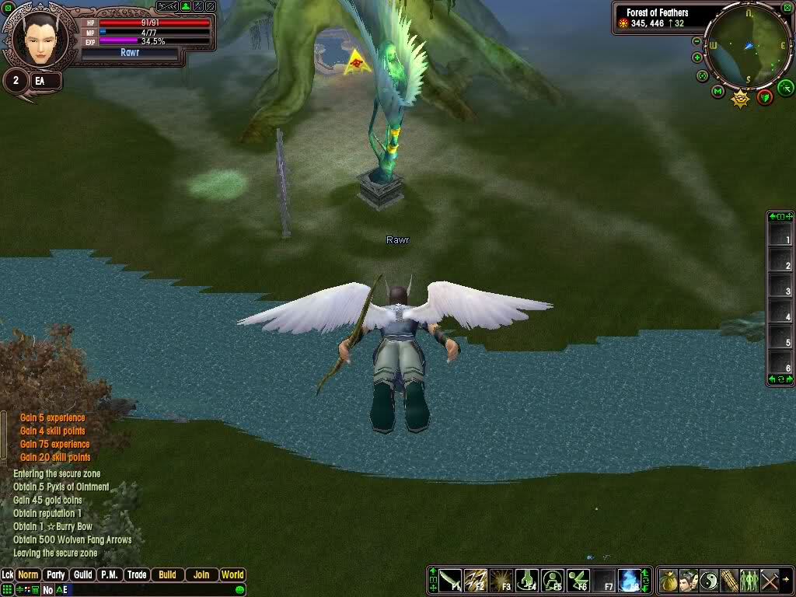 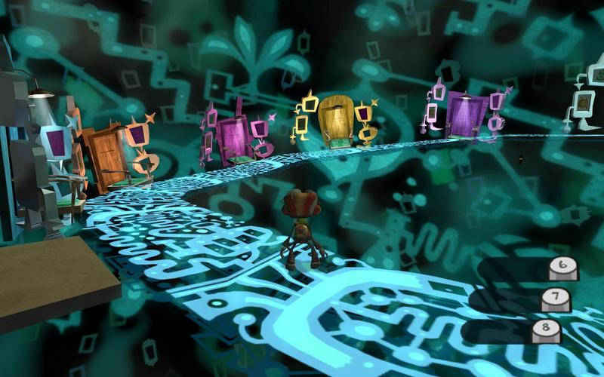

**Game Overview**

|  |  |
| --- | --- |
| **Game Summary** | Your soul ventures through the dangerous and unknown depths of your mind. |
| **Game Genre** | Single Player Third-Person Action Shooter/RPG |
| **Player Experience** | Cathartic, Abstract, Emotional, Tense, Sombre |
| **Game’s Theme** | Abstract representation of overcoming adversity and internal struggles |
| **Target Audience** | People looking for a way to cathartically and symbolically overcome problems with their mental health. Also, people who enjoy a good action game with some persistent RPG mechanics. 14+ |
| **Setting** | A visual representation of a person’s mind. |
| **Technical Details** | Software: Unity/Blender/GIMP  Platforms: PC (Mouse+Keyboard / Gamepad) |
| **Game Title Ideas** | The Phoenix Egg, Fall of the Phoenix, Phoenix Descent |
| **Launch Date** | December 31, 2017 |

**Basic Camera, Character, and Controls**

|  |  |
| --- | --- |
| **Camera** | Image result for third person rpg  Free-look third person camera |
| **Character** | A winged circular orb of light/color that shoots projectiles from above. A representation of the soul  Image result for navi ocarina of time |
| **Controls** | |  |  | | --- | --- | | **WASD** | On ground: Move forward/backward or strafe left/right  In air: Glide forward, hover w/ slight gravity, or glide left/right | | **Mouse Look** | Free look / aim | | **LMB** | Basic Ranged Attack (Hold for auto-fire) | | **RMB** | Special Ability (Hold to charge/channel) | | **Space** | Fly (Hold to charge if a jump charge is remaining and with enough energy) | | **Shift + WASD** | Dodge in a direction (with enough energy) | | **E** | Ultimate Ability (Instant spherical defensive ability) – Effect depends on charge build up. | | **F** | Interact with object or NPC | | **TAB/1+2+3/Wheel** | Switch special ability type | |
| **Resources** | Health  Stamina – Cost of evasive maneuvers, like flying, gliding, and dodging  Energy – Cost of special attacks  Defensive Charge – Cost of Ultimate. Depletes all current charge on use. Power depends on charge build up. |

**30 Seconds of Gameplay**

|  |  |
| --- | --- |
| **Context** |  |
| **Player Actions** |  |

**Gameplay Features**

|  |  |
| --- | --- |
| **Evasive Aerial Maneuvers** | Image result for flying rpg  Flight – Charge wings before shooting up into the air  Gliding – Use wings to glide gracefully towards the ground while attacking enemies from above  Dodging – Use wings to quickly evade attacks in all directions, both in the air and on the ground  Image result for bayonetta flip |
| **Basic Attacks** | Hold LMB to auto-fire – no gravity |
| **Special Attacks** | Channeled Spray (close range cone, high AoE, high damage)  Image result for tf2 flamethrower  Charged Projectile Orb (medium range, medium AoE, high damage)  Image result for orisa halt  Channeled Hit-Scan Laser (long range, single target, medium damage)  Image result for moira spray attack |
| **Persistent RPG Elements** | Basic Attack: Damage, firing rate, projectile speed, projectile size, homing ability, maximum range, piercing, effects on attack, effects on hit  Evasion: Maximum ascension height, minimum ascension height, jump charge speed, jump charge cost, number of jumps, gliding speed, gliding cost, dodge cost, dodge speed, effects on jump, effects while ascending, effects while charging jump, effects while gliding, effects on dodge, general move speed, maximum stamina, stamina regeneration  Defense: Maximum health, health regeneration  Special Attack (Spray): Cone width, damage, cost, cone range, effects on hit  Special Attack (Orb): Charge time, cost, damage, projectile radius, maximum range, effects on hit, effects on fire  Special Attack (Laser): Cost, damage, range, effects on hit  Ultimate Ability: Charge rate, sphere radius, length of ability, buff modifiers, move speed  Cosmetics: increased particle effects, wing styles, projectile trail  Methods of progression: Permanent stats, equipped auras, level power-ups |
| **Story Mode** | Five worlds, with three levels each  - Realm of Depression, Realm of Fear, Realm of Wrath, Realm of Greed, Realm of Pride  Three difficulties: Easy, Medium, Hard |
| **Arcade Mode** | Image result for junkenstein's revenge  Get placed in an arena and fight continuous swarms of enemies. Try and get a high score. Lots of power-ups scattered. |

**Story and Theme**

|  |  |
| --- | --- |
| **Protagonist** | Image result for navi ocarina of time  The winged soul. Can equip itself with five auras which orbit the player.  Types: Dodge, Jump/Glide, Basic Attack, Special Attack, Ultimate |
| **Antagonist** | Image result for inside out  Illusions, temptations, and nightmares of the mind |
| **NPC’s** | Image result for ghostly spirit guild wars  The victims of the situations in the levels. They give some dialogue and context to the situations they are facing. |
| **Main Objective** | To escape the cages of the mind/body and “transcend” |
| **Motivation** | The soul will die and wither away if it stuck in the mind for too long. |

**Enemy Design**

|  |  |
| --- | --- |
| **Overall Design** | All enemies have black, white, and their theme color. All enemies shatter on death, to promote the idea that they are products of the mind. |
| **Depression** | Image result for sad monster  Medium Health. Low damage. Medium attack range. Ground only. Slow move speed. Medium aggression range. Low attack speed. Slow projectile speed. Uses control effects like slow and sink on player. Main color: Blue |
| **Fear** | Image result for minion rpg  Low health. Low damage. Low range. Attack in swarms. Ground only. Low-Low attack range. High move speed. High attack speed. High aggression range. No special attacks, but there is a feeling of overwhelm with this creature. Makes one afraid to touch the ground. Main color: Purple |
| **Wrath** | Image result for rage demon  Low health. High damage. Medium attack speed. High move speed. Medium aggression range. Medium attack range. Can fly to a moderate height. Wild and unpredictable attack patterns. Main color: Red |
| **Greed** | Image result for poison monster  Very high health. Medium damage – high damage over time. High attack range. Ground only. Medium aggression range. Slow move speed. Low attack speed. Can create deadly area of effects on ground or in the air. Leave trails of vomit and slime. Main color: Green |
| **Pride** | Image result for sephiroth wingsImage result for paragon guild wars  High health. Medium damage. High attack range. Can fly high. Basic and advanced ranged attacks. Medium move speed. Medium attack speed. High aggression range. Have evasive abilities. Look like perfect, magical beings. Main color: Yellow |

**Level Design**

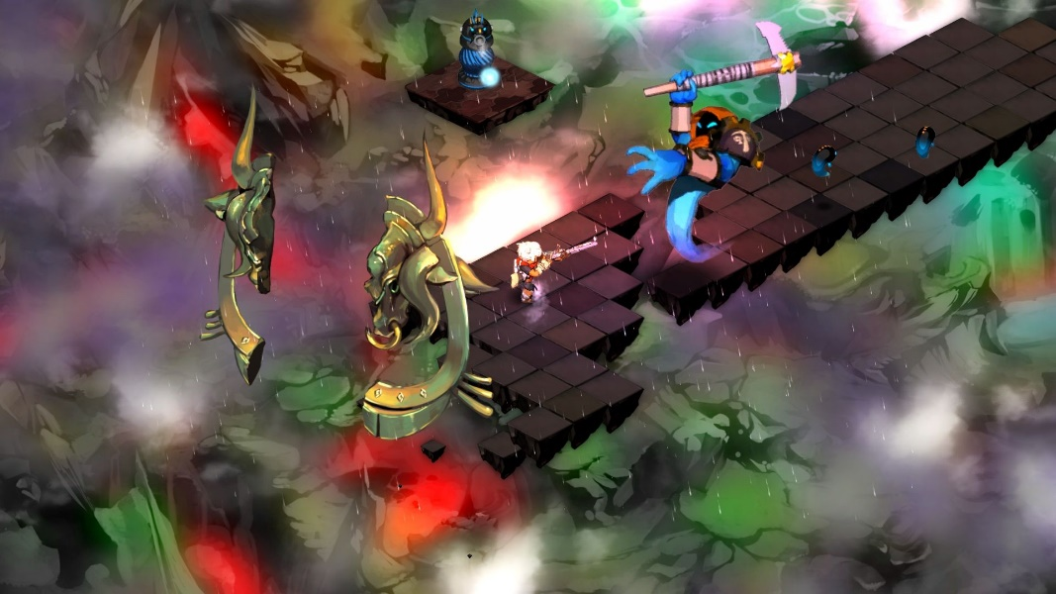

|  |  |
| --- | --- |
| **Overall Design** | Foggy, mysterious, hard to see in the distance.  Lots of black and white + themed color.  Areas of rest are marked by a wider variety of colors. World should get more colorful as the player defeats more enemies.  Minimalistic and abstract 3d art style.  Worlds and levels should vaguely represent real life experiences and objects.  Each object placed in a level should be related to the theme of that level.  As the worlds progress, combinations of previous worlds are included. |
| **Depression** | Main color: Blue. Element: Water/Vapour  1 – Past. During childhood. In school. Looking back very fondly.  Image result for daycare  2 – Present. An adult stuck in their room.  Image result for sad bedroom  3 – Future. During elderly age in a retirement home. Some elements of fear are introduced.  Image result for retirement home |
| **Fear** | Main color: Purple. Element: Ice/Storm  1 – Work. At an office.  Image result for stanley parable  2 – Relationships. At a bar.  Image result for bar  3 – Death. At a graveyard. Some elements of wrath are introduced.  Image result for graveyard |
| **Wrath** | Main color: Red. Element: Fire/Lava  1 – Abuse. At home. In a living room.  Image result for abuse at home  2 – Revenge/Assassination. In an urban gang environment.  Image result for gta gang  3 – War. On a battlefield. Some elements of greed are introduced (looting)  Image result for call of duty |
| **Greed** | Main color: Green. Element: Earth/Mud/Poison  1 – Gluttony. At a restaurant.  Image result for restaurant  2 – Materialism. At the mall.  Image result for mall  3 – Envy/Vanity. At the gym. Some elements of pride are introduced.  Image result for gym vanity |
| **Pride** | Main color: Yellow. Element: Air/Wind/Thunder  1 – Towards self. At a house of mirrors.  Image result for house of mirrors  2 – Towards others. Discrimination. In the church.  Image result for inside cathedral  3 – Towards God. At a library. “Tower of Babel”  Image result for tower of babel |

**Brainstorm / General Ideas**